Interactive Sales Dashboard in Power BI

**Problem:** Create an interactive sales dashboard in Power BI to analyze company performance using the visualizations listed below.

1**. Data Preparation**

• load the provided sale dataset into PowerBI.

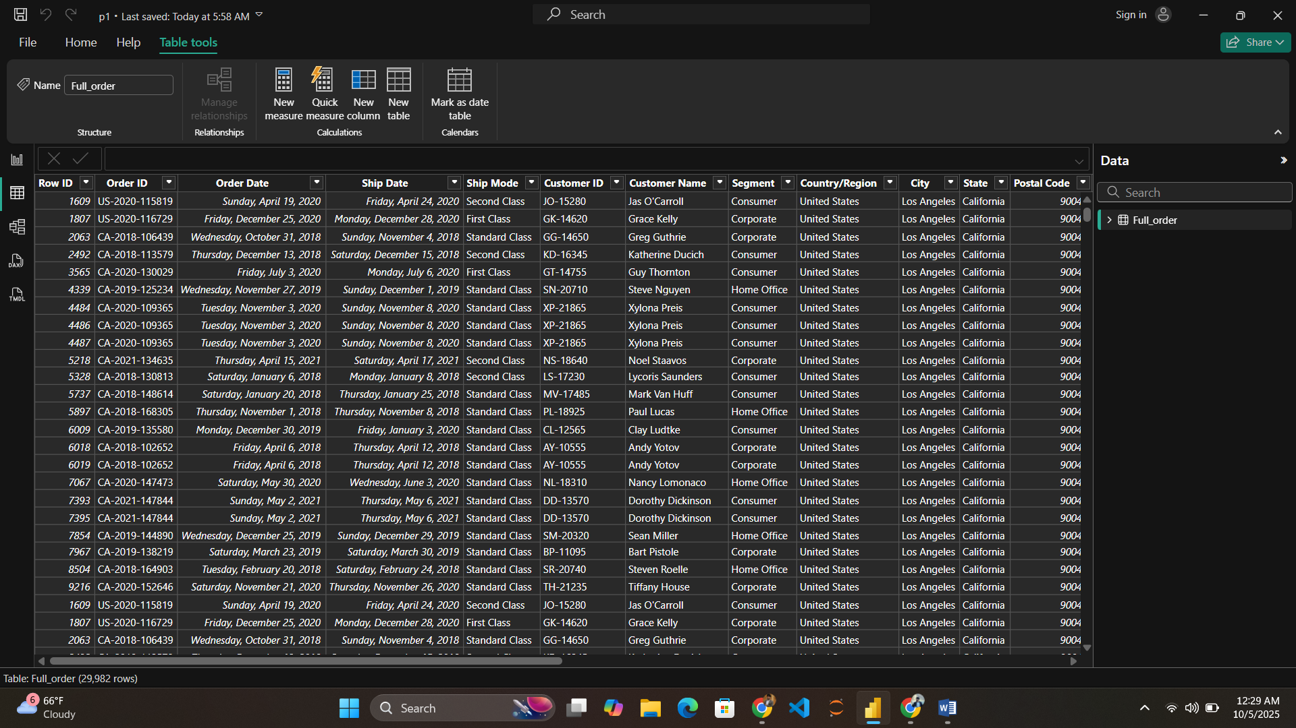

# 2. Create Visualizations

• Map: Show state-wise sales using a Filled Map.

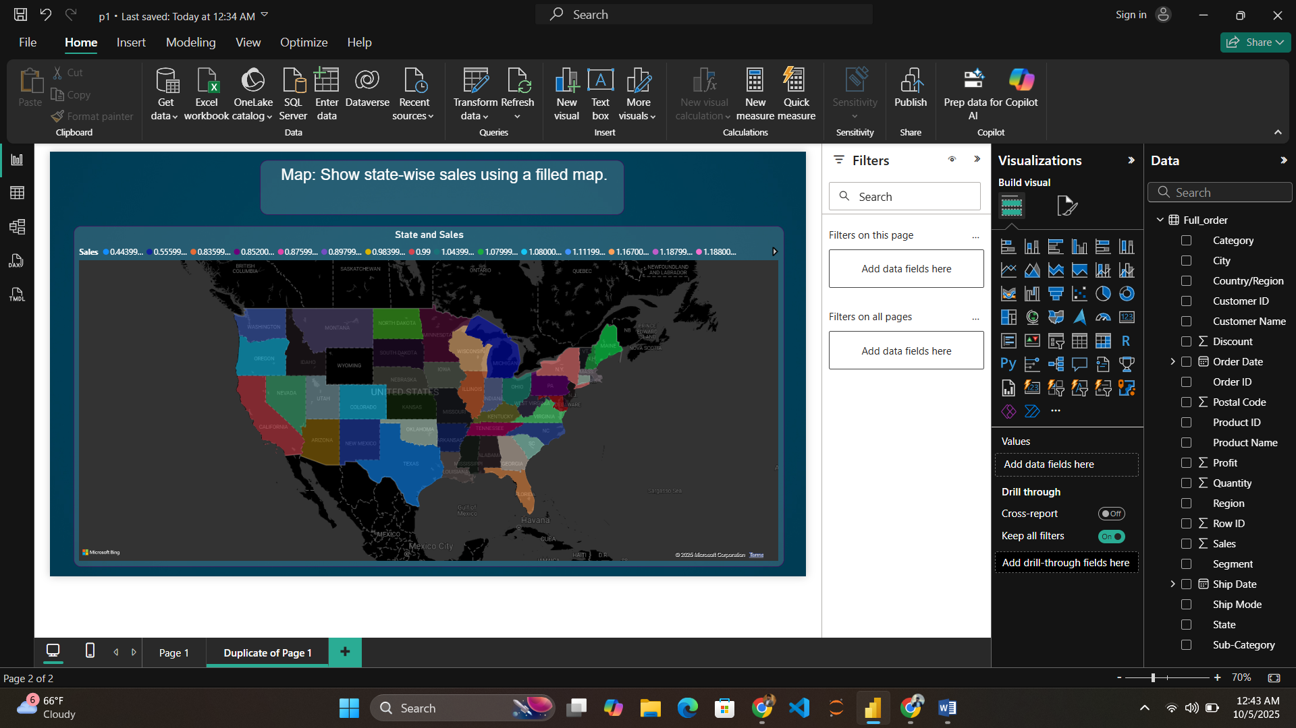

• Donut Chart: Display region-wise sales distribution.

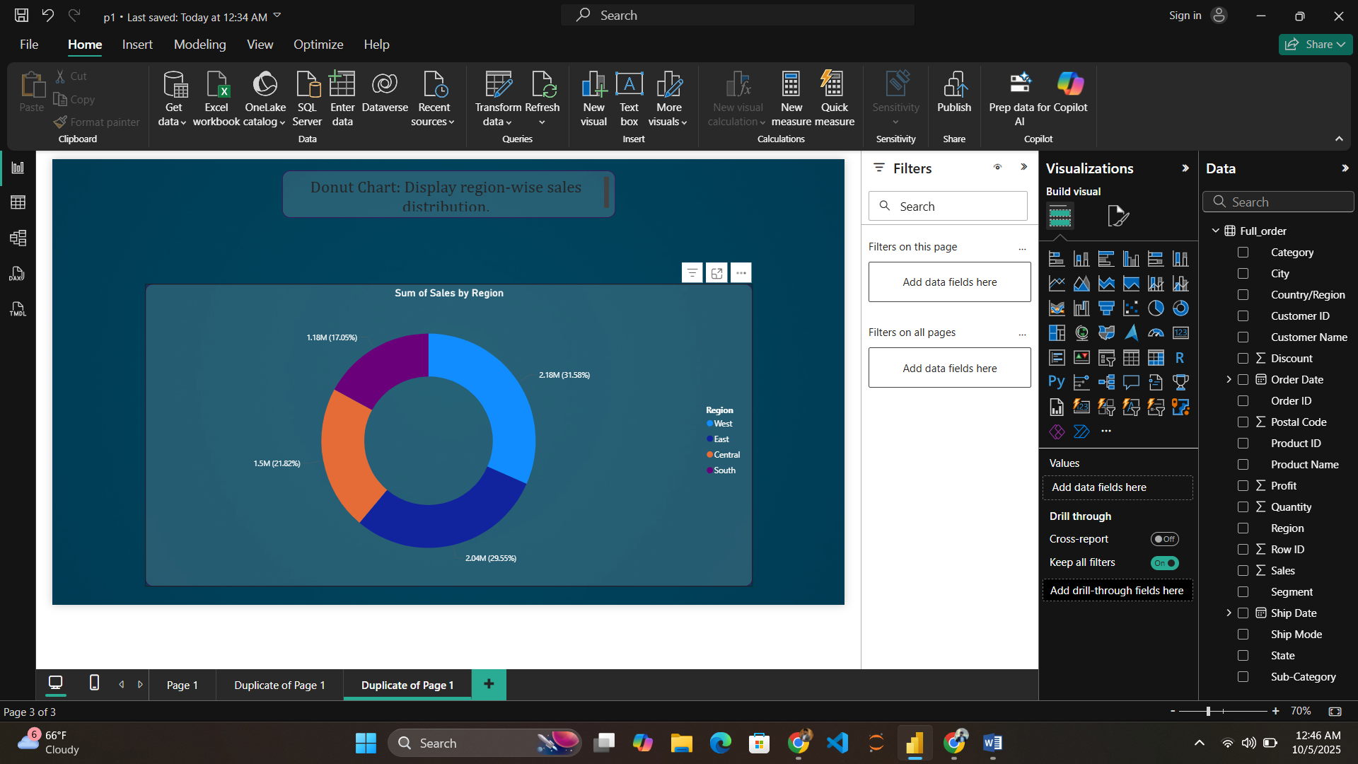

• Stacked Column Chart: Visualize year-wise sales.

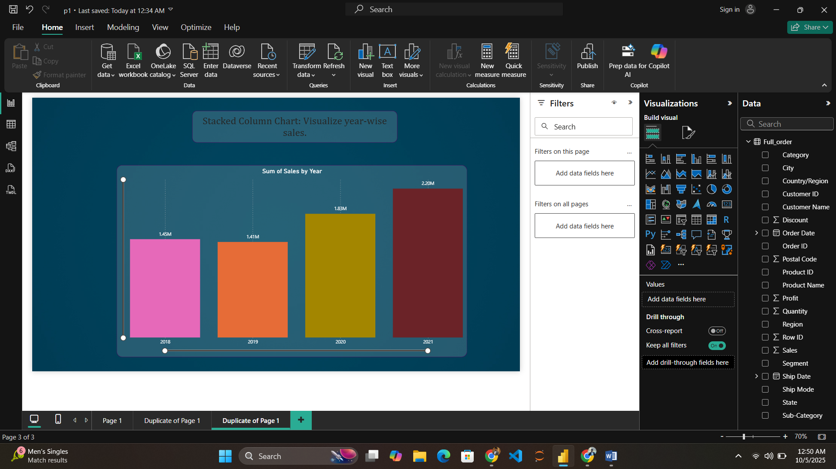

• Pie Chart: Illustrate category-wise sales proportions.

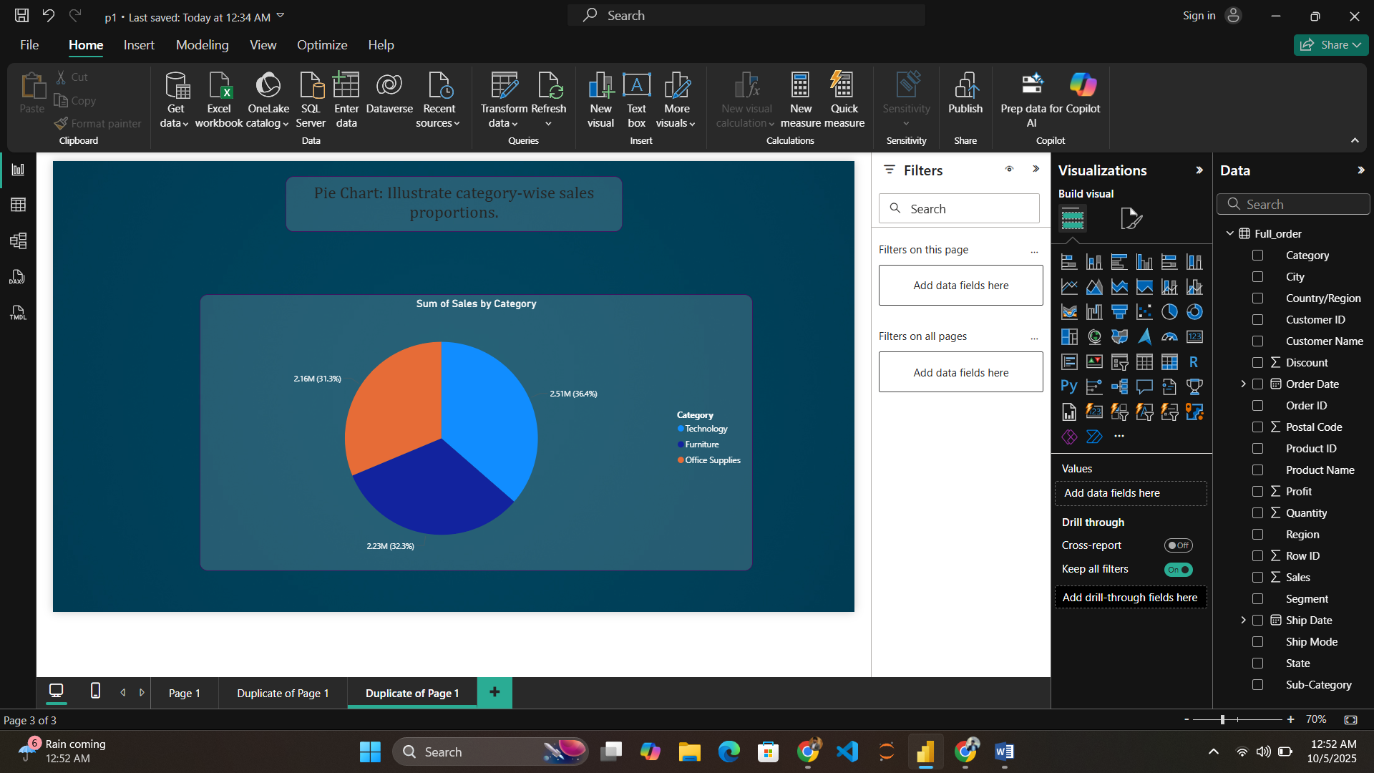

• Funnel Chart: Highlight sub-category-wise sales performance.

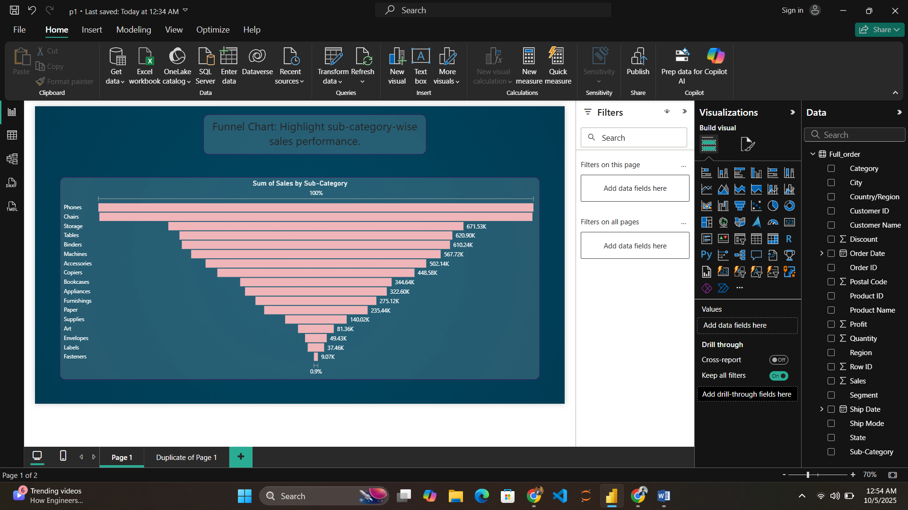

# 3. Dashboard Interactivity

•this screenshot is for west region (when we click on west region):  
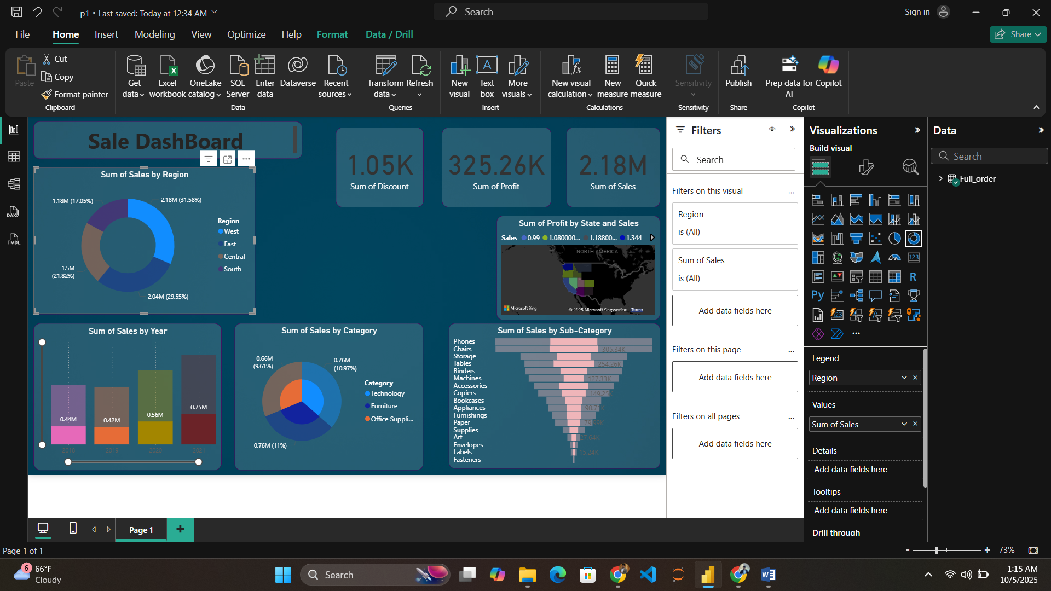

This screenshot for the central region (when we click on central region):

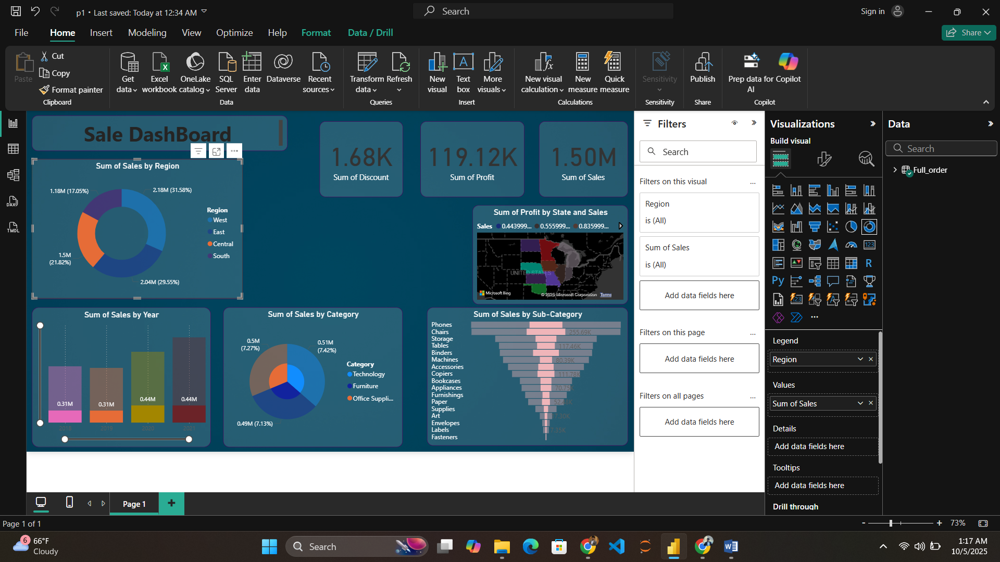

# 4. Insights & KPIs

• Add KPI Cards showing key metrics:  
 - Total Sales  
 - Total Profit  
 - Total Discount

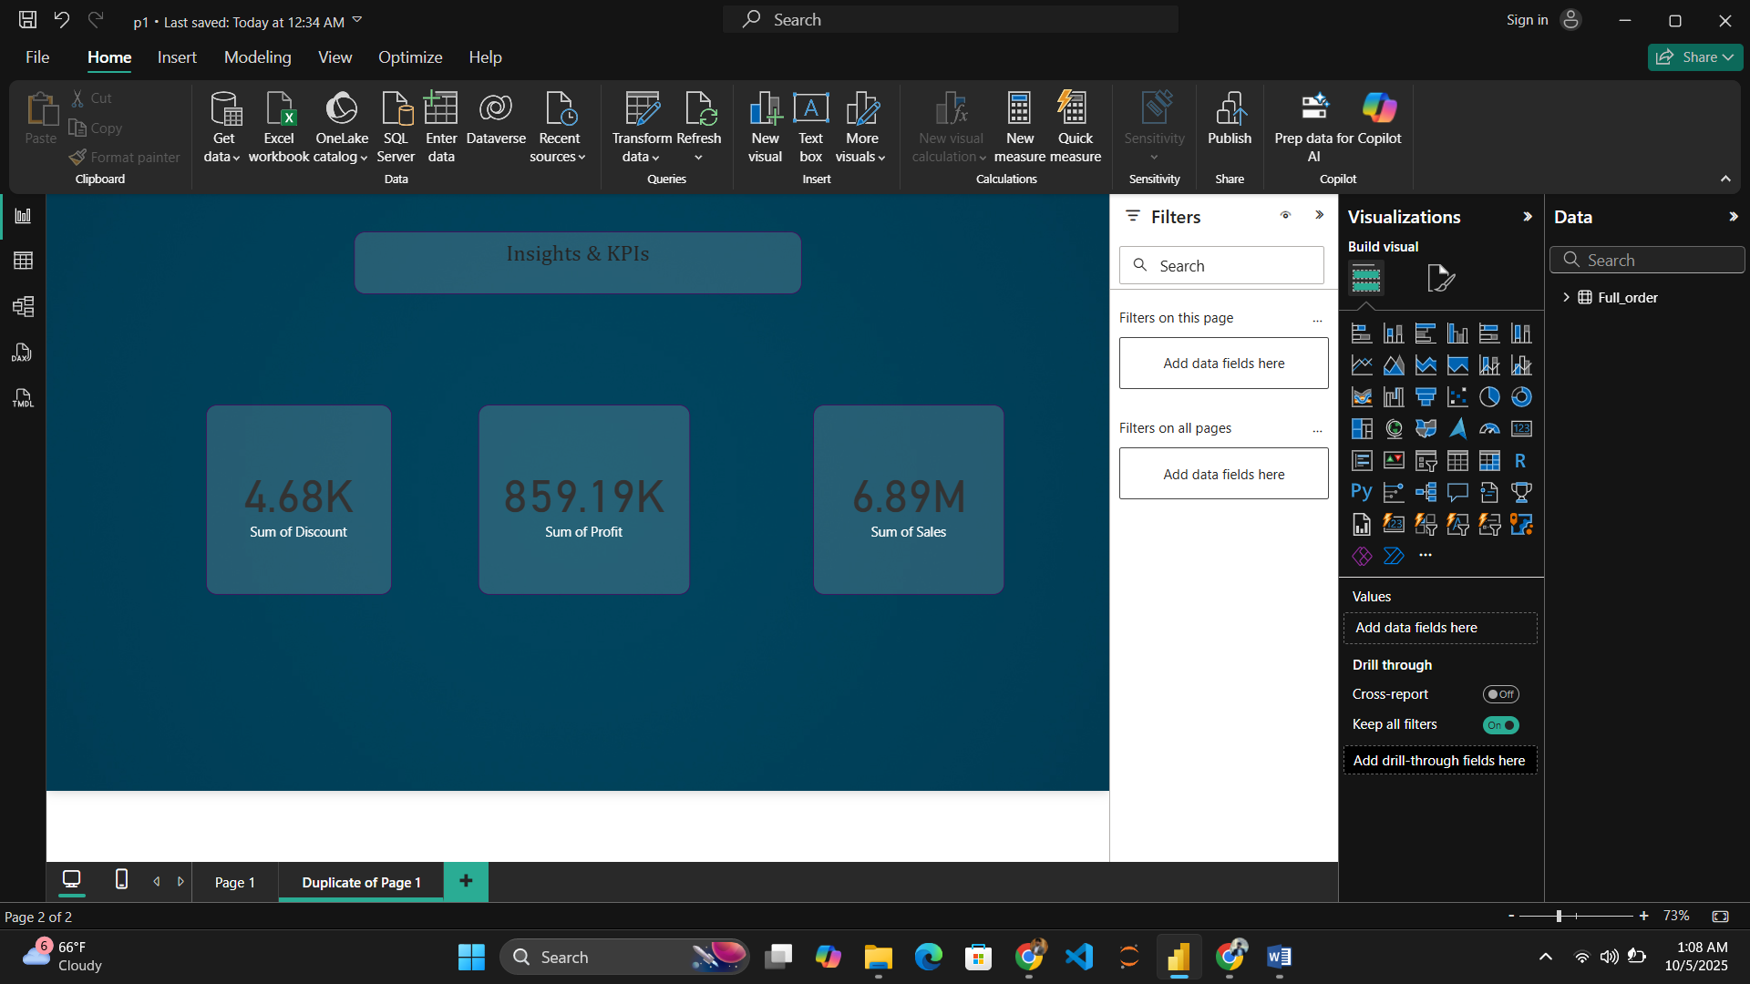

# 5. Formatting

• Use consistent color themes and professional font sizes.  
• Add a background color or image for visual appeal.  
• Ensure all labels, legends, and titles are clear and readable.

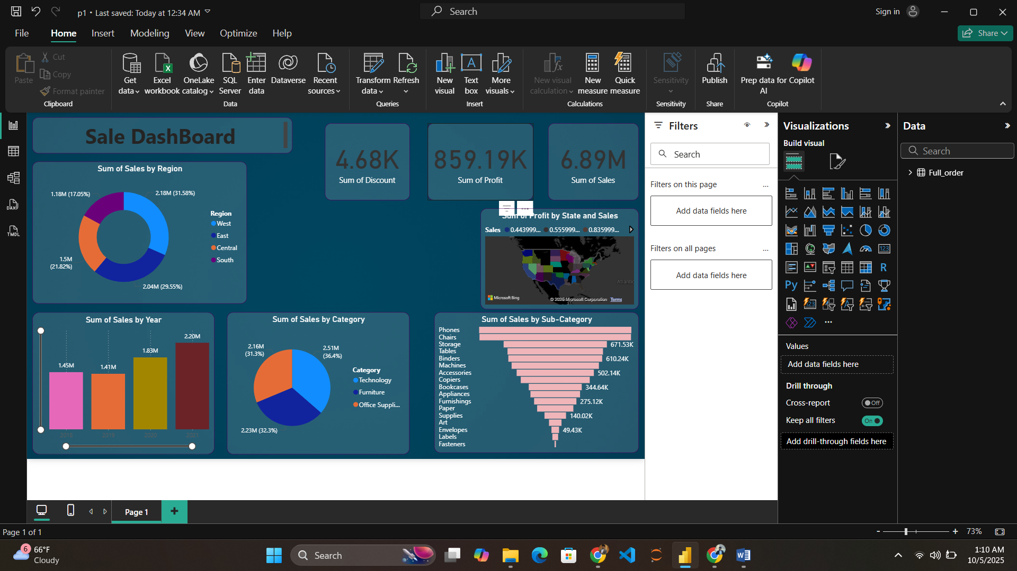h

**Here I attached also Screenshort of PDF view of Final Dashboard;**

